My Activity Schedule

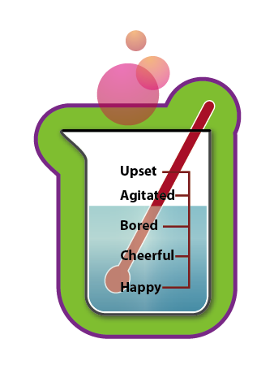

|  |  |  |  |  |
| --- | --- | --- | --- | --- |
| Day | Fun activity  what & when | Who’s involved? | Mood rating before | Mood rating after |
| Sunday |  |  |  |  |
| Monday |  |  |  |  |
| Tuesday |  |  |  |  |
| Wednesday |  |  |  |  |
| Thursday |  |  |  |  |
| Friday |  |  |  |  |
| Saturday |  |  |  |  |